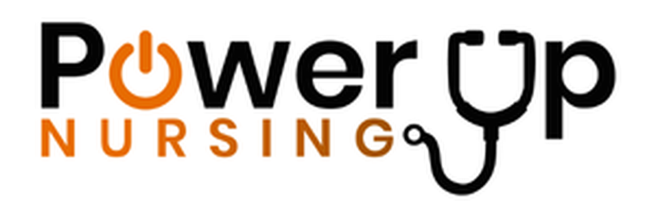
Power Up Nursing
www.powerupnursing.com
Dance It Out One Page Media Kit 2026

ONE PAGE MEDIA KIT FOR DANCE IT OUT 2026
Dance It Out is a national celebration organized by Power Up Nursing during National Nurses Week, recognizing nurses as the essential force behind patient care, hospital performance, and community health.
On Friday, May 8, 2026, hospitals across the United States will host joyful gatherings where nurses and healthcare teams celebrate through music, movement, and community connection.
Some hospitals will host their events on May 8, while others will hold celebrations throughout Nurses Month in May.
Why Dance It Out?
Nurses are the largest segment of the healthcare workforce and the frontline guardians of patient care. Yet the profession faces unprecedented levels of stress and burnout.
Dance It Out was created to:
• Celebrate nurses and their impact on American healthcare
• Promote movement, joy, and positive experiences for well-being
• Build community among healthcare teams
• Recognize nurses as a strategic force in healthcare success
• Invite communities to celebrate and support the nursing profession
Key Event Elements
Participating hospitals may include:
• Music and group dancing
• National sponsor giveaways
• Event signage and celebration materials
• Local and national media participation
• Refreshments and social gathering
• Recognition of nurses and healthcare teams
• Community engagement activities
Each hospital designs its own unique event.
Some events are open to the public, while others are internal staff celebrations.
National Participation
More than 25 hospitals in 25 cities across the United States are joining together for Dance It Out 2026.
Participating hospitals will be announced as events are finalized.
Quote from Power Up Nursing
“In all of my years of nursing and working alongside nurses, it has always amazed me that no matter how tired they are or how exhausting their shifts have been, they are always willing to celebrate through music, dance, and shared joy,” said Tanya Abreu, RN, CEO of Power Up Nursing.
“Dance It Out is our way of expressing gratitude to nurses across the country who serve so selflessly every day. We want to celebrate them with music, recognition, and a moment of collective joy that reflects the energy and compassion they bring to healthcare.”
Sponsor Quote
“CeraVe is proud to be involved with Dance It Out 2026. We believe the touch of nurses is one of the most powerful forces in healthcare, and we are honored to stand beside them as they celebrate Nurses Week with joy and community.”
How Hospitals Can Participate
Hospitals interested in hosting a Dance It Out event can register by April 1, 2026.
Contact:
info@powerupnursing.com
Sponsorship Opportunities
Companies interested in supporting nurses and participating in this national celebration can inquire about sponsorship opportunities.
Contact:
info@powerupnursing.com

About Power Up Nursing
Power Up Nursing is a national initiative dedicated to promoting and protecting the well-being of nurses as a core healthcare business strategy and as a driver of community health. Through programs, partnerships, and national initiatives like Dance It Out, Power Up Nursing supports nurses while advancing better outcomes for patients and healthcare systems.

Media Contact
Anel Tuyebayeva
Power Up Nursing
anel@powerupnursing.com

