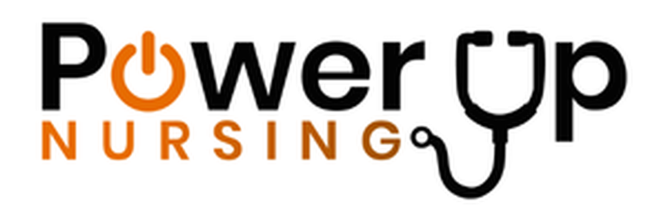
Power Up Nursing
www.powerupnursing.com
Dance It Out Local Sponsorship Letter Template 2026

[Hospital Letterhead]
[Date]
[Sponsor Name]
[Company Name]
[Address]
Dear [Sponsor Name],
At [Hospital Name], we are proud to celebrate and elevate the incredible nurses who care for our community every single day. This year, we are bringing that celebration to life through our upcoming Dance It Out event, a joyful and energizing experience designed to honor the heart, resilience, and humanity of nursing.
Dance It Out is more than a local event, it is part of a national movement taking place in 25 cities across the United States, united by one powerful message: nurses move us all to better health. Through music, movement, and connection, we are creating a space where nurses can recharge, feel seen, and be celebrated for the extraordinary work they do.
To make this event truly meaningful, we are seeking the support of valued community partners like you. We welcome both in-kind and financial contributions to help us bring this experience to life.
Sponsorship opportunities may include:
- Food and beverage donations to nourish our attendees
- Giveaways or wellness items to support nurse well-being
- Promotional items or coupons to include in event gift bags
- Financial contributions to support event production and programming
Your support will not only contribute to a memorable event but will also demonstrate your organization’s commitment to those who dedicate their lives to caring for others.
We would be honored to partner with you in celebrating our nursing community. Please feel free to contact us at [Contact Information] to discuss how you would like to be involved.
With gratitude,
[Your Name]
[Your Title]
[Hospital Name]
[Contact Information]

Event Details
Dance It Out – National Nurses Week Celebration
Location: [Hospital campus / plaza / lobby / courtyard / auditorium]
Date: Friday, May 8, 2026
Time: [Start Time – End Time]
Public invited: [Yes / No / Limited access]
Additional activities may include:
• Music and group dancing
• Nurse recognition moments
• Sponsor giveaways
• Refreshments
• Photo opportunities
• Community celebration of healthcare teams

National Sponsors include:
CeraVe, Circular

Local Sponsors
[List Local Sponsors]
Organizations interested in supporting the celebration may contact:
[Local contact name]
[email]

About Dance It Out
Dance It Out is a national celebration organized by Power Up Nursing that honors nurses and promotes their well-being as a vital healthcare strategy. Hospitals across the United States host Dance It Out events during National Nurses Week and throughout the month of May to celebrate the nurses who move communities to better health.

About [Hospital Name]
[Hospital boilerplate paragraph here]
Example structure:
[Hospital Name] is a leading healthcare provider serving [CITY / REGION], offering comprehensive medical services and compassionate care to patients and families throughout the community. With a dedicated team of nurses, physicians, and healthcare professionals, the hospital is committed to improving the health and well-being of the communities it serves.

Media Contact
[Name]
[Title]
[Hospital Name]
Phone: [###-###-####]
Email: [email]

