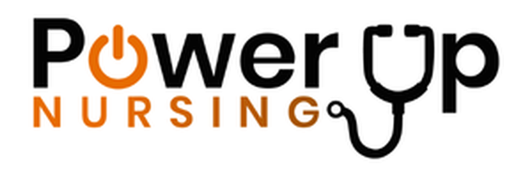
Power Up Nursing
www.powerupnursing.com
Dance It Out National Press Release Template 2026

NATIONAL PRESS RELEASE TEMPLATE FOR DANCE IT OUT

FOR IMMEDIATE RELEASE

More Than 25 Hospitals Across 25 U.S. Cities to “Dance It Out” for Nurses During National Nurses Week

Nationwide celebration highlights the nurses who move communities to better health
MIAMI, FL — [Month Day], 2026 — More than 25 hospitals and healthcare systems in over 25 cities across the United States are joining together this spring to celebrate nurses through Dance It Out, a vibrant national initiative recognizing the essential role nurses play in patient care, hospital performance, and community health.
Organized by Power Up Nursing, Dance It Out invites hospitals to celebrate their nursing workforce with music, movement, and community appreciation during National Nurses Week and throughout Nurses Month in May.
The official national celebration takes place on Friday, May 8, 2026, during National Nurses Week, though many hospitals will host their celebrations on different days throughout the month.
Each participating hospital designs its own unique event, bringing nurses, healthcare teams, community partners, and sponsors together in joyful recognition of the profession that forms the backbone of American healthcare. Dance It Out events may include music, group dancing, sponsor giveaways, educational messaging about well-being, refreshments, and community engagement.
The events celebrate a powerful truth:
Nurses move us all to better health.
Hospitals across the country are using this moment to demonstrate in a colorful and uplifting way how deeply nurses contribute to the well-being of patients and the health of their communities.

Celebrating the Heartbeat of Community Health
Nurses represent the largest segment of the healthcare workforce and are often the most trusted professionals in healthcare. Their work touches nearly every moment of the patient experience, from bedside care to patient education and emotional support for families.
Dance It Out recognizes the energy, compassion, and resilience nurses bring to healthcare every day while also highlighting the importance of movement, positivity, and community connection for nurse well-being.
“Dance It Out is an experience for nurses that celebrates the rhythm of their work and the movement of their daily lives as they bring patients and entire communities better health,” said Tanya Abreu, RN, CEO of Power Up Nursing.
“Through Dance It Out we are bringing together hospitals, nurses, and corporate sponsors in a symphony that puts the spotlight squarely on nurses and the extraordinary role they play in healthcare.”
Abreu noted that the celebration is accompanied by a special Dance It Out anthem created for the occasion, designed to capture the spirit of the nursing profession.
“In the viral Dance It Out for the Nurses song created for this celebration, the chorus really says it all:
Dance it out, dance it out, let the whole world see
Nurses moving everyone to better energy.
Hands up, masks on, still we find that groove.
If you're standing with the healers, better make your body move.
Dance it out, dance it out, feel the hope come through.
Every step, every smile says we'll get you through.
That message captures exactly what nurses do every day — bringing energy, hope, and healing to their patients and their communities.”
National sponsors of Dance It Out include CeraVe and Circular Smart Ring.

Hospital Participation
Hospitals across the country are hosting Dance It Out celebrations as a way to recognize their nursing workforce and demonstrate their commitment to nurse well-being.
Events may take place in hospital courtyards, community plazas, hospital campuses, or other venues designed to bring together nurses and healthcare teams in celebration. Some events will be open to the public while others will be internal celebrations for hospital staff.
Hospitals interested in participating in Dance It Out 2026 may contact:
info@powerupnursing.com
For a list of participating hospitals and healthcare systems: https://www.powerupnursing.com/dance-it-out
About Power Up Nursing
Power Up Nursing is a national initiative dedicated to promoting and protecting the well-being of nurses as a core healthcare business strategy and a driver of community health. Through research, partnerships, and national programs such as Dance It Out, Power Up Nursing works to strengthen the nursing workforce while improving outcomes for patients, hospitals, and communities.
Media Contact
Anel Tuyebayeva
Power Up Nursing
Email: anel@powerupnursing.com

