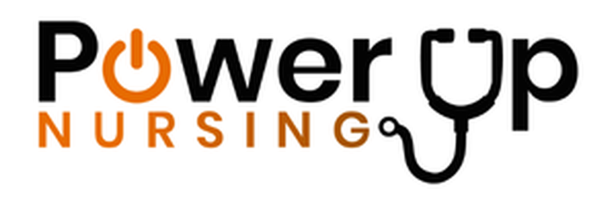
Power Up Nursing
www.powerupnursing.com
Dance It Out Local Hospital Press Release Template 2026

(LOCAL HOSPITAL PRESS RELEASE TEMPLATE)

FOR IMMEDIATE RELEASE

[Hospital Name] to Host “Dance It Out” Celebration for Nurses During National Nurses Week

Hospital joins nationwide movement recognizing nurses who move communities to better health
[CITY, STATE] — [Month Day, 2026] — [Hospital Name] will join hospitals across the United States on Friday, May 8, 2026, to celebrate nurses during National Nurses Week through Dance It Out, a nationwide initiative organized by Power Up Nursing.
The celebration recognizes nurses as the driving force behind patient care, hospital performance, and community well-being.
At [TIME] on May 8, nurses, healthcare staff, and community members will gather at [LOCATION / VENUE] to celebrate the nurses who keep [CITY NAME] healthy through music, movement, and community appreciation.
Dance It Out events are being held at hospitals in cities across the country, with each hospital creating its own unique celebration of the nursing profession.

Celebrating the Nurses Who Move Us to Better Health
Nurses are the largest and most essential segment of the healthcare workforce and play a critical role in improving patient outcomes, supporting families, and strengthening community health.
Dance It Out celebrations highlight the importance of joy, physical movement, and positive experiences in supporting the well-being of the nursing workforce.
“Our hospital is proud to participate in this national movement to recognize and celebrate nurses, because we know nurses are the cornerstone of our hospital and of community health here in [CITY NAME],” said [CEO NAME], [TITLE] of [HOSPITAL NAME].
“On May 8, we will move with our nurses and celebrate their extraordinary contribution to the health of our community. Dance It Out is a joyful way to recognize the dedication, compassion, and resilience nurses bring to their work every single day.”

Event Details
Dance It Out – National Nurses Week Celebration
Location: [Hospital campus / plaza / lobby / courtyard / auditorium]
Date: Friday, May 8, 2026
Time: [Start Time – End Time]
Public invited: [Yes / No / Limited access]
Additional activities may include:
• Music and group dancing
• Nurse recognition moments
• Sponsor giveaways
• Refreshments
• Photo opportunities
• Community celebration of healthcare teams

National Sponsors include:
CeraVe, Circular

Local Sponsors
[List Local Sponsors]
Organizations interested in supporting the celebration may contact:
[Local contact name]
[email]

About Dance It Out
Dance It Out is a national celebration organized by Power Up Nursing that honors nurses and promotes their well-being as a vital healthcare strategy. Hospitals across the United States host Dance It Out events during National Nurses Week and throughout the month of May to celebrate the nurses who move communities to better health.

About [Hospital Name]
[Hospital boilerplate paragraph here]
Example structure:
[Hospital Name] is a leading healthcare provider serving [CITY / REGION], offering comprehensive medical services and compassionate care to patients and families throughout the community. With a dedicated team of nurses, physicians, and healthcare professionals, the hospital is committed to improving the health and well-being of the communities it serves.

Media Contact
[Name]
[Title]
[Hospital Name]
Phone: [###-###-####]
Email: [email]

